Student’s name | …………………………………………………….…… | Grade | 7
Subject | Computer | Week No. | 7
Lesson Title | Cryptography | Unit
Worksheet No. ( 7 )

Question A: write the correct name of each part.

Encryption algorithm | Interceptor | Decryption algorithm

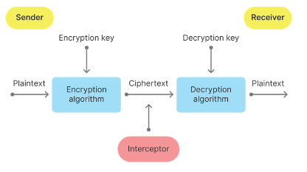
Good Luck
………………….

………………….

………………….

